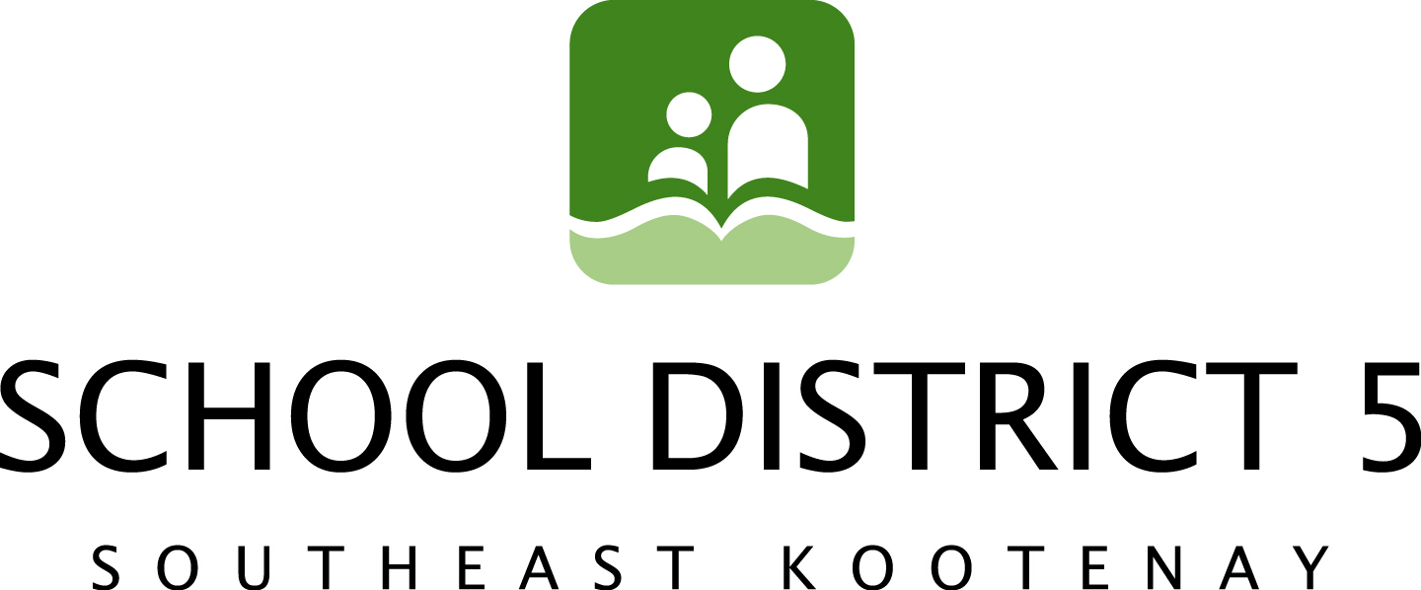

April 15th, 2014

SD5: Hats off to the White Hatter

Students in School District 5 (SD5) are probably some of our more tech-savvy digital citizens. But using the latest and greatest apps, chat rooms and social networks doesn’t necessarily mean that they know how to keep themselves –and their friends— safe.

That’s where Darren Laur of Personal Protection Systems Inc, steps in. Dubbing himself “The White Hatter” Darren self-describes as one of the “good guys” and he’s dedicated his life to helping others stay safe on-line. Most recently, Darren showcased the latest on internet safety and social media to parents at Key City Theatre on April 9th and to students in Cranbrook on April 10th and 11th and the Elk Valley on April 14th and 15th.

Currently a serving Staff Sergeant with the Victoria City Police Department, Darren has over 28 years of law enforcement experience with a strong background in on-line and social media investigations. He is an internationally recognized safety expert and advocate, award-winning author and renowned international keynote speaker.

Trustees Trina Ayling and Chris Johns attended the Mount Baker Secondary School (MBSS) presentation while Trustee Patricia Whalen attended the Laurie Middle School (LMS) presentation and Trustee Bev Bellina attended the Elk Valley presentation on April 14th.

“Darren provided some excellent resources for our school community,” says Ayling. “He understands digital culture on the same level as our students. He ‘gets’ what they do, and why they do it. He’s not about limiting their on-line experiences, he’s about providing them with the tools to enhance these experiences in a safe environment.”

Johns agrees saying, “There were at least two-dozen high school students surrounding Darren following his presentation. Trustee Ayling and I spent close to an hour talking with his wife and business partner, Beth, before Darren was free to speak with us.”
The presentations were two hours in length and covered over two dozen need-to-know topics about digital media including cell phone, Web Cam, and chat room safety, why your “digital Dossier” matters (and how to protect it) and the law as it relates to Cyber Bullying and Sexting.
“I’m pretty tech-savvy –or so I thought”, says Whalen, “but after listening to Darren I realize how much I didn’t know. I think a lot of our students fall into this category, and I’m glad Darren was able to provide them with some insight into how to avoid the pitfalls of technology while still enjoying the benefits.”

To date, Darren and Beth have presented their Internet and Social Media Safety programs to over 200 Schools throughout British Columbia, Saskatchewan and the United States. For more information on The White Hatter visit http://personalprotectionsystems.ca/, read his blog @ http://thedigitalsheepdog.ca/ or visit his facebook page, The White Hatter.

Contact:

Frank Lento, Chairperson, SD5 Board of Education 250-423-7607 Trina Ayling, SD5 Media/Communications Committee 250-489-1006

