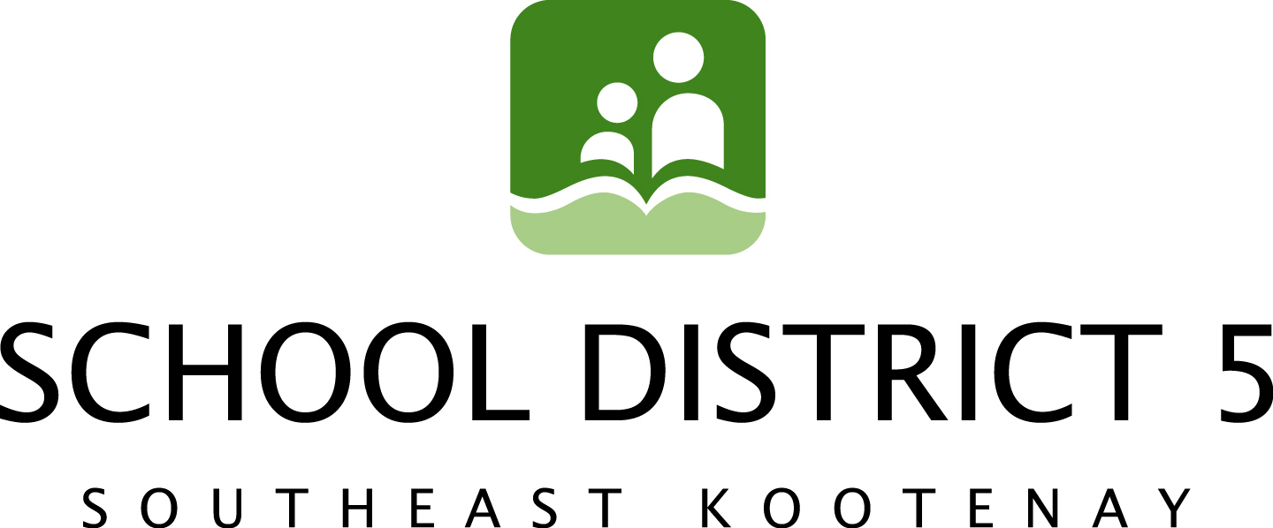
Media Release April 8th, 2014
RDEK Support for Key City Theatre, Mount Baker School Project

On April 4th, 2014, the Key City Theatre Society (KCTS) made a presentation to the Regional District of East Kootenay (RDEK) to request their support on the combined Mount Baker School replacement and new regional theatre project.

Since 2008, the SD5 Board of Education has been working on replacement of Mount Baker Secondary School (MBSS) as a Neighbourhood Learning Centre (NLC), an initiative designed to bring educational services and community resources together in a new high school building.

According to Mount Baker Replacement Committee chair, Trustee Chris Johns, the process began with extensive public consultations with the community* that led to the determination that Key City Theatre should be a main community component within a replacement MBSS/NLC.

On December 20, 2012 SD5, the KCTS and the City of Cranbrook reaffirmed their relationship with a signed partnership agreement in the design of theatre space in the new MBSS. In February, the trio extended an invitation to MP David Wilks and RDEK Board Chair, Rob Gay to discuss the possibility of expanding their partnership to better reflect the cultural diversity and geographical reach of the Key City Theatre and its patrons.

“The Theatre is dedicated to expanding community involvement by presenting professional artists spanning a wide spectrum of art and culture”, says Sandra Cave, chair of the KCTS. “As a result of these efforts, over one-third of patrons are from somewhere else in the region.”

“This is much bigger than just Cranbrook”, agreed SD5 Board Chair, Frank Lento. “Fundamental to the success of this project is the ability to bring together other community partners to help build the project. Both MLA, Bill Bennett and most recently MP David Wilks have expressed support for this initiative. The next logical step is to engage the Regional District.”

During the presentation to the RDEK, Lento made three requests –that they provide letters of support for any applications for grants, that they set aside a Reserve Fund commencing in 2015 towards replacement of the Key City Theatre; and that they consider contributing to the replacement and future operations of the Key City Theatre.

In response to these requests, the RDEK carried a motion to provide letters of support for applications for grants and a motion to send a request to staff to report back on the feasibility of setting aside a reserve fund and/or contribute to the replacement and future operations of the theatre. Completion of the report is expected later this year.

“We’re very optimistic about the progress that’s being made on this initiative”, says Lento. “It’s very encouraging to have the RDEK part of our team and we look forward to formalizing a partnership in the near future.”

*To view the Phase I and Phase II Community Consultation Process reports, please visit our website at sd5.bc.ca.

Contact:
Chris Johns, SD5 Mount Baker Replacement Committee 250-426-5338
Trina Ayling, SD5 Trustee Media/Communications Committee 250-489-1006

