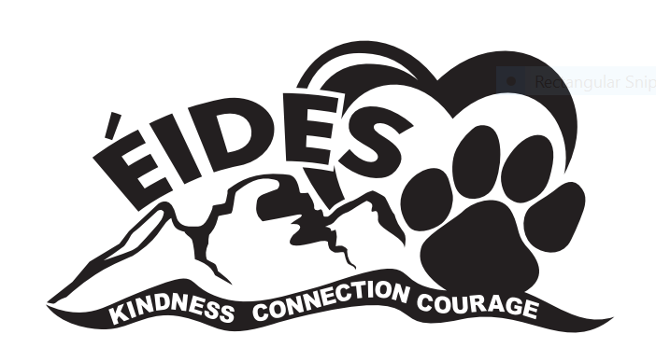
ÉCOLE ISABELLA DICKEN ELEMENTARY
2024-2025 School Supply List
Grade 4 French Immersion

1 Package of lined paper (200 sheets)
3 Exercise books (72 page, 8mm ruled with margin)
1 Spiral notebook (at least 100 pages)
7 Duotangs (Plain-Do Not Label)
1 Pencil case (large)
4 Pens - 2 red and 2 blue
12 pencils (Good quality HB pencils)
(No decorative pencils please, no plastic coated pencils as they damage our electric pencil sharpeners.)
1 Package of pencil crayons
1 Set of coloured markers
3 Expo dry erase markers
1 Black permanent marker (Sharpie - ultra fine tip)
1 Black permanent marker (Sharpie – fine tip)
1 Desk size pencil sharpener
1 Set of earphones (not expensive, put in Ziploc)
1 Ruler (metric)
2 White erasers
2 Glue stick
1 Box of Kleenex
1 1” three-ring binder
1 Calculator
1 Clean sock for wiping whiteboards
1 Pair of running shoes for gym & indoor use. NON-MARKING SOLES!
(NO skate shoes.)

Due to teacher preferences, additional resources required during the first week of school may be requested by teachers. Please label all supplies including all crayons and pencils & BRING all supplies labeled on the FIRST DAY of school.

Quality is essential as cheaper products do not hold up. Replacements may be needed throughout the year. It is encouraged to re-use supplies from previous year.

Thank you for sending your child well prepared.

