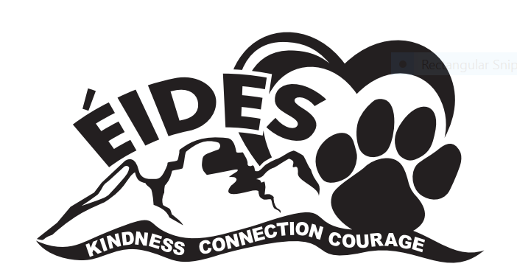
ÉCOLE ISABELLA DICKEN ELEMENTARY
2024-2025 School Supply List
Grade 3

20 Good quality (Canadian/USA made) HB pencils (sharpened)
No plastic-coated pencils – they damage our electric sharpeners
1 Pencil sharpener (no battery-operated sharpeners)
4 White vinyl erasers
1 Package pencil crayons (16 - 24 Laurentian or Canadian made)
1 Package washable felt markers (24 colour set)
2 Black (fine point) Sharpie marker
2 Ultra-fine tip black Sharpie markers
6 Dry Erase markers
1 Pencil Box
3 Large glue sticks
1 Pair of Scissors
1 Ruler (metric)
8 Duo-tang folders (1 each of yellow, orange, green, purple, blue, red, 2 black)
2 Interlined notebooks (dotted lines, 72 pages ruled)
1 Lined loose-leaf paper (400 sheets) Wide Ruled
1 Plain white paper (8 ½” x 11”) package of 100
1 Pair of headphones (not expensive, stored in a labeled Ziploc bag)
1 Extra-large Ziploc bag
1 Box Kleenex (200’s)
1 Pair of running shoes (NON-MARKING SOLES)
Due to teacher preferences, additional supplies may be requested. Your teacher will provide you with a list of any additional resources required during the first week of school. Please label all supplies, including all crayons and pencils. Bring all supplies labeled on the first day of school. Quality is essential, as cheaper products do not hold up. Replacements will be needed throughout the year. If possible, please re-use pencil crayons, rulers, scissors, binders etc. from previous year instead of buying new ones.

Thank you for sending your child well prepared.

