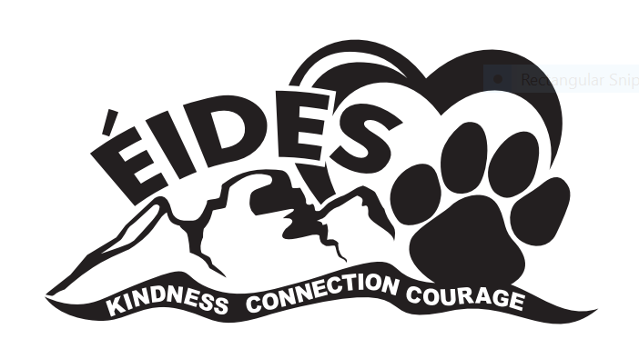
ÉCOLE ISABELLA DICKEN ELEMENTARY
2024-2025 School Supply List
Grade 2

3 Hilroy exercise books, dotted, interlined (blue cover, 72 pages) NO half and half
8 3-pronged duotangs (1 each of red, orange, yellow, green, blue, purple, black, white)
1 Extra 3-pronged RED duotang for music
24 Good quality (Canadian/USA made) HB pencils, (sharpened)
No plastic-coated pencils – they damage our electric sharpeners
4 White erasers (Faber Castall)
2 Black Sharpie markers
3 Large glue sticks
1 Package pencil crayons
1 Package of Wax Crayons
1 Package of felt markers
4 Expo dry erase markers; wedge (not fine point)
2 large boxes Kleenex tissue
4 New Ziploc bags 3.75 L - to be used for supplies, readers, etc.
1 Large (fabric) pencil case
1 Pair of earphones for computers in a LARGE labelled ZIPLOC bag
1 Set of water based paints
1 1.5” binder (to put agenda in)
1 Pair of pointed scissors
- Metric ruler
- Good quality pencil sharpener
- Individual sandwich size Ziploc bags
1 Sketchbook
1 Pair running shoes * Shoes must leave NO marks on floors!
No skate shoes. No laced runners unless your child can tie his/her own shoes.

Due to teacher preferences, additional supplies may be requested. Your teacher will provide you with a list of any additional resources required during the first week of school. Please label pencils, markers and Pencil crayons.
Quality is essential, as cheaper products do not hold up. Replacements will be needed throughout the year. Please re-use supplies from previous years.

Thank you for sending your child well prepared.

