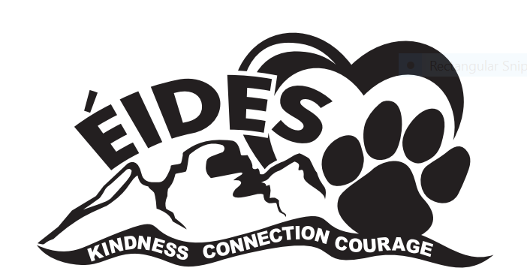
ÉCOLE ISABELLA DICKEN ELEMENTARY
2024-2025 School Supply List
Grade 1

1 pair of scissors (Fiskars only)
1 1” white hard cover binder with inside pocket and clear outside cover
2 Hilroy blue exercise books (Plain Pages)
6 Multi-coloured 3-pronged Duo-tangs (no plastic folders)
1 Crayola Paint Set (round disc) (24 colors)
1 Elmer’s white liquid glue
4 Large glue sticks (yellow UHU brand, no purple)
2 Boxes Kleenex tissues (100’s)
24 HB pencils, sharpened (yellow Canadian or USA made) No plastic-coated pencils as they damage our electric sharpeners.
1 24 box Crayola wax crayons
4 White erasers (Faber Castall)
2 Fine point, black Sharpies
2 Expo dry erase markers - 4 pack (black)
1 Package of Crayola coloured pencils (24 pack) No plastic-coated pencils as they damage our electric sharpeners.
1 Pencil case
1 Box XL freezer bags (12” x 15”)
1 Box sandwich zippered Ziploc bags
2 packages of wide/fat markers (scented are fine; not permanent)
1 Pair of runners * Shoes must leave NO marks on floors!
No skate shoes. No laced runners unless your child can tie his/her own shoes.

Due to teacher preferences, additional supplies may be requested. Your teacher will provide you with a list of any additional resources required during the first week of school.
Quality is essential, as cheaper products do not hold up. Please label supplies. Replacements will be needed throughout the year.
Please re-use supplies from the previous year, if possible, instead of buying new ones.

Thank you for sending your child well prepared.

