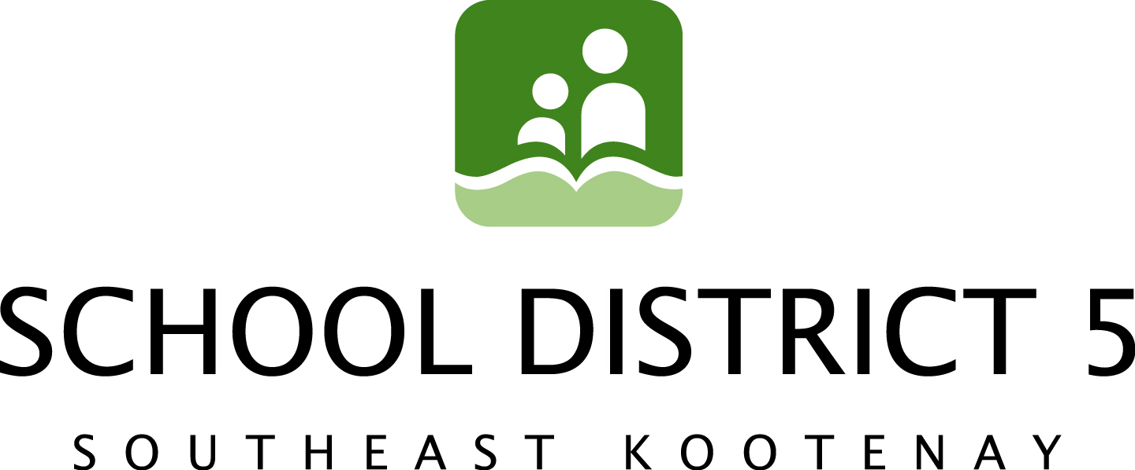

April 23rd, 2014

Former SD5 Student Wins National Championship

School District 5 (SD5) has never been shy to recognize the accomplishments of its staff, students and partner groups. From Superintendents to the District Parents Advisory Council chair, SD5 has boasted everything from Diamond Jubilee to Motivational award winners and just about everything in between.

April’s Board meeting was no exception to the practice of recognition when Board Chair and former inductee to the Hockey Hall of Canada, Frank Lento, announced a win very close to his own hockey heart.

According to Lento, it was just last month that former Fernie Secondary School (FSS) Graduate, Shannon (Smith) Desrosiers, 32, and her husband, Matt, 34, won the National Collegiate Athletics Association (NCAA) National Title with the Clarkson Women’s Hockey team in New York.

“Shannon grew up in Fernie and both her parents were teachers with the District, says Lento. “It’s always nice to see a former student successful and making a difference for other young people.”

Shannon and her husband currently live in Potsdam, New York as head co-coaches for women’s hockey at Clarkson University, NY. They have a two-year old daughter and are expecting their second child later this year. This was the school's first NCAA national title in any sport.

Shannon’s mother, Kathy Smith, taught in SD5 for thirty-five years. Her father, Gary, taught for thirty years. Both parents were also actively involved in a number of sports.

Contact:

Frank Lento, Chairperson, SD5 Board of Education 250-423-7607 Trina Ayling, SD5 Media/Communications Committee 250-489-1006

