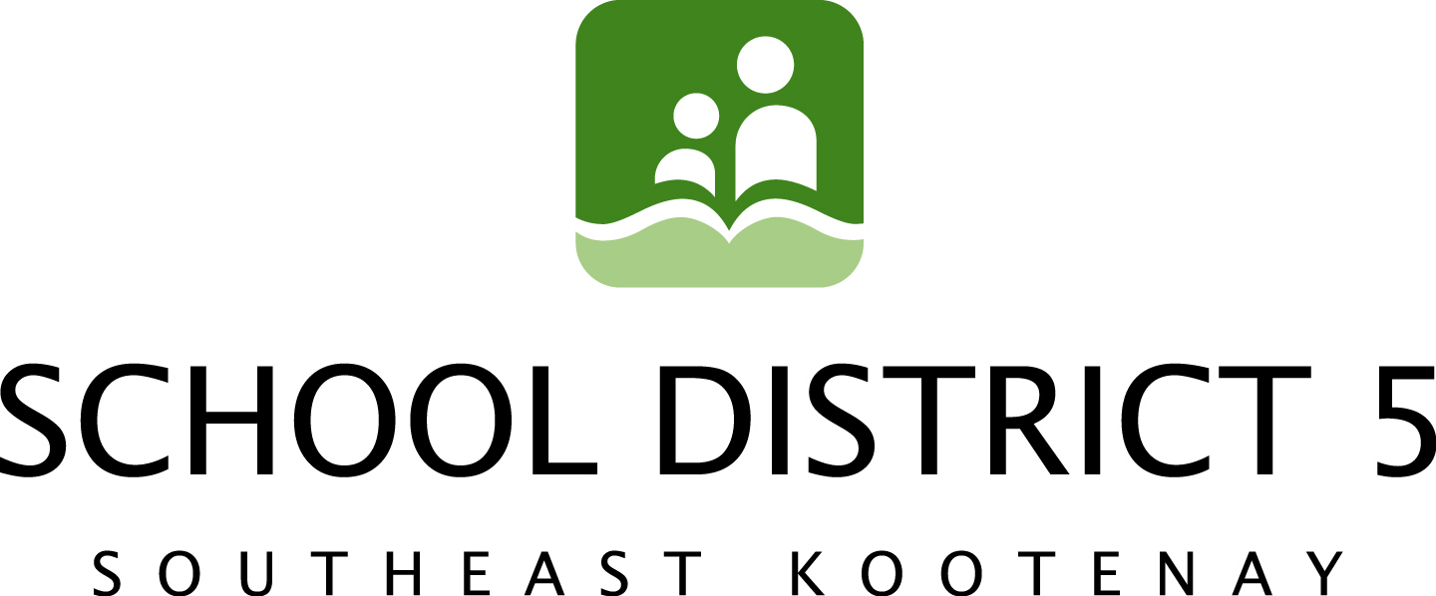

May 21, 2014

SD5 Board Passes Balanced Budget, Includes Separate “Needs Budget”

School District 5 Trustees passed a balanced budget of $52,297,605 at last week’s Board meeting in Elkford. The Board was facing a net funding shortfall of $800,000 according to SD5 Board Chair Frank Lento.

Lento says that although this year’s budget once again reflects the Board’s commitment to ensure that no educational programs were cut, classroom sizes were maximized in order to stretch limited dollars and submit a balanced budget.

“While very little has changed in the way of enrolment projections or programming needs we find ourselves -- once again—dealing with what we believe is an inherent structural shortfall within the funding system itself,” says Lento, who defines the shortfall as a financial situation where available revenue is persistently and chronically less than what many Districts believe is needed to pay for the delivery of publicly-mandated programs and services.

Trustee Chris Johns agrees, pointing out that the current funding formula for Districts work fine in a world where prices never go up. “Unfortunately that’s not the world in which we live. Inflation alone produces cost increases to the District of over one million dollars year over year. In addition to inflation the District also has to pay for carbon offsets, MSP premium increases, BC Hydro rate increases, and the HST.”

“Government is well aware that the K-12 system is experiencing cost pressures as a result of inflation (and aging school facilities), says Johns. “This information –along with a number of recommendations – was presented to them months ago in the Select Standing Committee on Finance and Government Services 2014 budget report.”

The Select Standing Committee on Finance and Government Services is an all-party committee of The Legislative Assembly. Each fall, the Committee holds province-wide public consultations on the next provincial budget. The Committee, which is empowered to examine, inquire into and make recommendations with respect to the budget consultation paper prepared by the Minister of Finance, released its Report on the Budget 2014 Consultations in November 2013.

Lento says the provincial government needs to acknowledge the current reality and work with trustees to make adequate investments in the future education of our province.

“SD5 continues to submit a “needs budget” along with our balanced budget to government each year. This “needs budget” reflects the educational reality of District needs rather than the budgetary reality of government grants. We need government to recognize this reality, to re-examined the current funding formula and work with Boards constructively to protect public education.”

To view the Select Standing Committee on Finance and Government Services Report on the Budget 2014 Consultations report, visit http://www.leg.bc.ca/cmt/finance/reports.asp.

Contact:

Frank Lento, Chairperson, SD5 Board of Education 250-423-7607 Trina Ayling, SD5 Media/Communications Committee 250-489-1006

