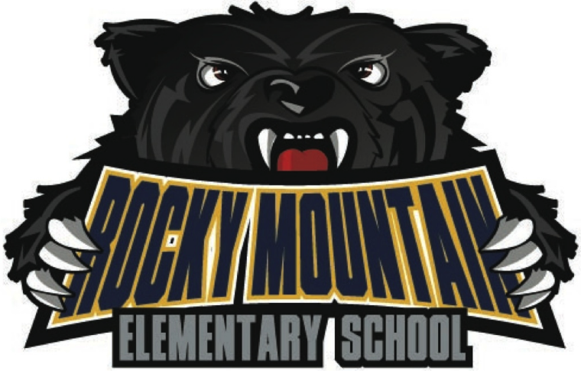

Rocky Mountain Elementary School Handbook 2026/27

2500 Balmer Dr, Elkford, BC V0B 1H0
(250) 865-4625
Website: https://www.sd5.bc.ca/school/rmes/Pages/default.aspx#/=

Dear Parents and Students,
As the RMES admin team, we look forward to making the school year a great one. We have an amazing team who provide quality learning experiences for all our students in a safe, caring, friendly, supportive, and inclusive environment.
We are looking forward to a productive partnership with you to ensure our children can achieve their highest potential. We recognize that in order to be successful in school, students need support from both the home and school.
We know a strong partnership with you will make a great difference in your child’s education. As partners, we share the responsibility for our children’s success and want you to know that we will do our very best to carry out our responsibilities.
It is important to us that everyone who steps through our doors, teachers, students, and parents, are excited to be here.
If you have any questions or concerns, please do not hesitate to phone the school at (250) 865-4625 or email us at jennifer.adams@sd5.bc.ca or Jennifer.attorp@sd5.bc.ca. If parents would like an interview with a teacher, counselor, or administrator, please phone Rocky Mountain Elementary and request that the school arrange a convenient time.
Sincerely,
Ms. Jennifer Attorp, Principal
Ms. Erin Jones, Vice Principal

RMES Mission Statement
The mission of Rocky Mountain Elementary School is to provide a quality education which will enable all students to reach their full potential within a caring environment. In achieving that end, we focus on the core subject areas, bully prevention, emotional-regulation and social/emotional competence.
RMES Value Statement
We value:
- Students and staff engaged in life-long learning
- Opportunities for collaboration, cooperation, and leadership for all learners
- A positive, safe, and happy learning environment
- Respect for self, for others, and for property

School District 5 Mission Statement

To provide students with equitable, quality, educational opportunities in a safe, supportive environment through the efforts of a caring, professional team in cooperation with students, parents and communities.

RMES School Goals:
Goal #1: Literacy – To improve our students’ literacy proficiency using a Multi-Tiered System of Support framework that addresses the needs of all students so that by June 2028, at least 80% of all students will read grade level texts accurately, fluently, and for meaning according to the Acadience Reading K-6 benchmark.

Goal #2: Citizenship – To ensure that our students leave our school as positive, caring and contributing members of society

Our Shared Mission, Vision, and Values
Let’s strive to keep these in mind as we work together to engage students at home and school. We can also review these annually and make necessary changes as well as include new contributions from our RMES community.

Rocky Mountain Elementary School Staff
TITLE​​ | NAME​ | EMAIL​
Principal | Jennifer Attorp | jennifer.attorp@sd5.bc.ca
​Vice Principal | Erin Jones | erin.jones@sd5.bc.ca
​Secretary​ | Gena Scott | gena.scott@sd5.bc.ca
Kindergarten​ | Grace Tsao | grace.tsao@sd5.bc.ca
​​Kindergarten | Renee MacCormack | renee.maccormack@sd5.bc.ca
​Grade 1 | Vanessa Pettifor​ | vanessa.pettifor@sd5.bc.ca
​Grade 1/2 | Taylor Wurmlinger | taylor.wurmlinger@sd5.bc.ca
​​Grade 2/3 | Sam Stremecki | sam.stremecki@sd5.bc.ca
​Grade 3 | Katie DeBruycker | katie.debruycker@sd5.bc.ca
​​Grade 4 | Katelon Kennedy | katelon.kennedy@sd5.bc.ca
Grade 4/5 | Maddie Porter | maddie.porter@sd5.bc.ca
​Grade 5/6 | Summer Bisson | ​​summer.bisson@sd5.bc.ca
​​Grade 6 | Justin Hart | justin.hart@sd5.bc.ca
Band | ​​Clara Macleod | ​clara.macleod@sd5.bc.ca
​Library/Technology/Gym | ​​Miranda Akkerman | ​​​​ miranda.akkerman@sd5.bc.ca
​Student Services | ​​ Kathleen Wick | kathleen.wick@sd5.bc.ca
​Counsellor | ​​TBD | ​
​Youth Care Worker | Ms. Lisa Payne | lisa.payne@sd5.bc.ca
Indigenous Education Support Worker | Ms. Rebecca Robertson-Bauer | ​rebecca.bauer@sd5.bc.ca
​​Educational Assistants | Kayla Osmachenko  Kaitlyn Devolin  Victoria Brewer  Tristan Giroux | Kayla.osmachenko@sd5.bc.ca  Kaitlyn.devolin@sd5.bc.ca  Victoria.brewer@sd5.bc.ca  Tristan.giroux@sd5.bc.ca

RMES Parent Advisory Council (PAC)
The Parent Advisory Council (PAC) is the legally recognized voice of the parents (or guardians) in our school system. It is a partnership between the educators (school and school board), parents and students. Any parent who has a child enrolled in our school is a member of the PAC. Parents can participate in determining policies, services, achievement levels and enjoyment for their children at school. The PAC's fundraising efforts provide financial support for the goals determined by its members. It is our right and responsibility to share in the mission of educating our children. Your opinion matters: meetings are once a month September through June in the evenings.
Please check the school newsletter or Facebook pages for dates and times. EVERYONE IS WELCOME to attend our meetings and childcare is always provided.
Join us on Facebook - RMES PAC Elkford for up-to-date information on current events and activities!
Email: rmespac@yahoo.ca

RMES Bell Schedule

8:00 AM | Secretary Arrives
8:05 AM | First Bus Arrives
8:45 AM | Warning Bell: Students Come In
8:50 AM | Classes Begin
11:30 AM | Lunch
12:20 PM | Classes Resume
1:40 PM | Recess
1:55 PM | Classes Resume
3:00 PM | Dismissal
3:05 PM | First Bus Leaves
3:20 PM | Second Bus Leaves
3:30 PM | Secretary Leaves

RMES SUPPORT PROGRAMS
In addition to the regular classroom instruction, RMES provides a wide variety of assessments and services that address students who need additional supports. We screen students 3 times per year with Acadience universal screening which assesses foundational reading skills. We use this data to provide supports, specific to students' individual needs.

LEARNING ASSISTANCE PROGRAM/SUPPORTS
Available for children who have specific difficulties in academic areas such as Language Arts and Mathematics. Our Student Services Teacher along with the School Based Team (SBT) and parents develop individual educational programs (IEP) to meet the needs of each child that requires extra academic, physical, or social/emotional supports.

YOUTH CARE WORKER - Lisa Payne
Provides direct and indirect support to teachers, administrators, parents, students, community and others in the management of behaviors which interfere with personal, educational and social growth. They work in cooperation with the School Based Team, Director of Instruction, Student Services, and the community.

EDUCATIONAL ASSISTANT
Provides direct and indirect support to teachers in the implementation of programs and support of students.

INDIGENOUS EDUCATION SUPPORT WORKER - Rebecca Robinson-Bauer
Provides direct and indirect support to teachers, administrators, parents, students and the community. Works in cooperation with the School Based Team, Director of Instruction, Student Services, the local indigenous community, and other agencies to support aboriginal students. They also play a role in helping all students understand indigenous history and culture.

SPEECH LANGUAGE PATHOLOGY
What do Speech-Language Pathologists (SLPs) do?
Within the school environment SLPs work with students, their families and the staff to support them with any communication difficulties they may have. Areas include:
•Articulation/pronouncing words clearly
•Expression of language (e.g. grammatical errors, short sentence length, vocabulary, word finding difficulties, etc.)
•Understanding of language (e.g. following instructions, vocabulary, retaining information, etc.)
•Stuttering
•Early literacy skills
•Use of language for social interaction
•Development of play skills
•Communication difficulties as a result of hearing loss. Any communication difficulty is a barrier to education. Communication skills are essential for success in work and play
The Speech-Language Program at RMES:
Nichaela Williams, SLP, is at RMES twice a week for the calendar year. Julie Nish, SLP Assistant, is also at RMES daily during the school year. Nichaela and Julie work with children individually, in small groups and in the classroom.

HOSPITAL-HOMEBOUND
Students who are away from school for ten (10) or more consecutive days because of illness may be eligible for home instruction.

VISITORS TO THE SCHOOL
- Visitors are asked to check in at the office. Since class disruptions should be kept
to a minimum, visitors are asked to leave messages or items brought to school at the
office, complete with the student's name. If visitors are volunteering or moving
around the school, they will be required to wear a visitor pin/sticker and sign in.
- Volunteers at Rocky Mountain are requested to complete a criminal records check.
This is a district initiative to ensure the safety of our children.

BIKE RULES
Note: it is the law that helmets are to be always worn, but it is the parents' responsibility to enforce this.
- No bikes are to be ridden on school property (walk them to and from the bike rack)
- No one should be staying in the bike rack area. Bikes have been vandslized and injuries have resulted. Students are to drop off and leave bike rack area.
- E-Bikes: students must be 14 years or older to ride e-bike (see notice from RCMP below)

SCOOTERS AND SKATEBOARDS
Scooters and Skateboards can be ridden to school but not on school property. We strongly encourage proper safety equipment (helmets and pads), but it is the parents' responsibility to enforce this. If these modes of transportation are used on the school grounds, they will be confiscated and brought to the office where parents will be requested to pick them up

E-Scooters: e-scooters are currently not legal in Elkford (the community is not participating in the e-scooter pilot project- see notice from the RCMP

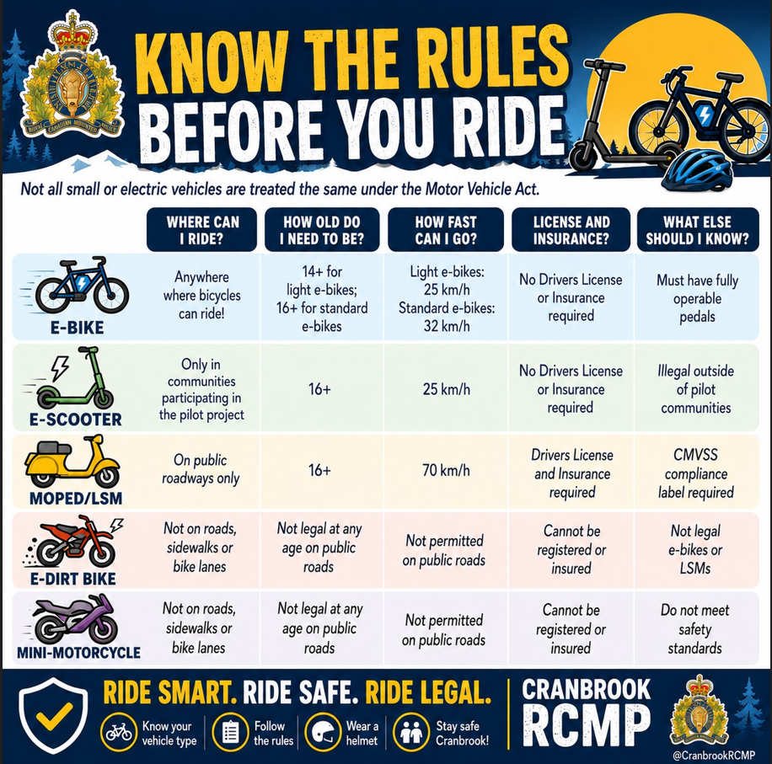)

INJURIES, FIRST AID and MEDICAL ALERT
•Injuries and accidents during the year are inevitable. Our procedure for reporting and handling accidents or injuries is very thorough. All children injured while on the school grounds will receive immediate attention. Parents will be informed by phone of any serious injury their child has sustained.
•Please communicate with the school any allergies, medical alert and/or life-threatening conditions your child has. We will complete a "Medic Alert Planning Form" so that the school has a complete understanding of procedures and responses in the event of an emergency.

LEAVING SCHOOL GROUNDS
Once students arrive at school, it is expected that they remain on the school grounds until dismissed to go home for lunch or until after school dismissal. Students may not leave the school premises without written permission. Students are expected to go directly home after dismissal. They are encouraged to walk home with a friend.

LOST AND FOUND
The container for lost and found clothing is in the hallway. Other valuables are turned in at the office. Unclaimed items are sent to local social agencies or disposed of in December and June. Students are not encouraged to bring valuables to school. If they do, they do so at their own risk.

ATTENDANCE
From our point of view, it is vital that children attend school regularly and punctually. Absence from school impedes a pupil's progress. If absent, parents are required to enter absence using School Messenger/Safe Arrival (see instructions below) or phone the school and leave a message indicating that your child will not be at school and stating the reason for the absence. Each morning and afternoon, the secretary verifies all unaccounted absences. Your cooperation in communicating any absences is greatly appreciated.

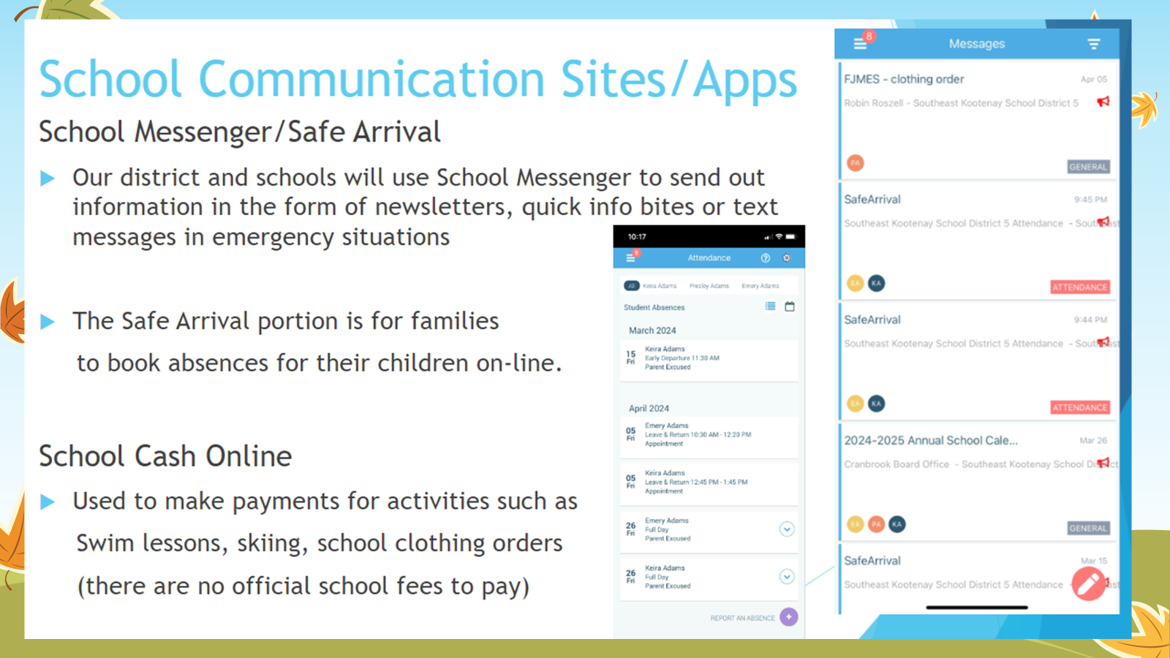

PICK-UP AND DROP-OFF STUDENTS
In order to avoid a serious safety hazard for our students, we ask parents to ensure that students are neither picked-up or dropped-off in the bus drive through zone in front of the school. The main parking lot is a ‘no through’ zone during school hours; busses, handicap and emergency vehicles only. If you are picking up or dropping off your children, please do so at the new designated parking areas on Balmer Crescent, or above the school on Deerborne. Please note, there is no longer a visitor parking area on campus.

SUPERVISION OF STUDENTS
All students are to go directly to the RMES playground when they arrive at school in the morning. No students should be waiting at their classroom doors at the front of the building, as there is no supervision for them there. Parents bringing their children to school and who wish to stay until the morning bell rings should check into the office first and then make their way to the playground area until the morning bell sounds.

LUNCH STUDENTS
Students staying for lunch will remain in the designated area for the eating period and will remain on the school property throughout the lunch period. Students who choose not to follow the lunch rules and/or display inappropriate behaviour will be required to meet with a principal to determine a course of action in consultation with the parents and supervisors.

INDOOR DAYS
Due to extremes in weather, there are times when we allow students to come into the school when they arrive, at recess, or at lunch. Although it is difficult to make hard and fast rules, the general guidelines for an ‘indoor day’ are as follows:
- minus 20 C or colder (including the wind factor)

On ‘indoor days’ all students must remain in the school because supervisors are in the building. We are hesitant to call ‘indoor days’ too often because children need fresh air and a chance for some activity to balance the rest of their school day. Please help us by ensuring your children are dressed appropriately in cold and inclement weather.

DRESS CODE
To make our school a comfortable, safe place for everyone, we believe home and school need to cooperate in the matter of dress.
The following are specific guidelines to help clarify the dress code:
- No clothing with vulgar, violent, or suggestive logos
- A pair of indoor shoes must be worn daily

TEXT AND LIBRARY BOOKS
Students are loaned texts, books and supplementary resource materials during the year. We endeavor to keep these books and resources in good shape. Our students are expected to return their texts and supplementary resources in good shape. Students are expected to replace damaged or lost school resource material.

TOBACCO AND CANNABIS FREE DISTRICT
The Board recognizes that the use of tobacco products is a health, safety and environmental hazard for students, employees, visitors and school facilities. No student, staff or school visitor is permitted to use any tobacco or cannabis product on the school ground at any time including non-school hours.

USE OF CELL PHONES AND DIGITAL DEVICES
Students may carry cell phones or other digital devices and may use them as follows:
•Cell phones and other digital devices may not be used during school times.
•Students may carry cell phones and/or digital devices but they must be turned off and in their back packs on school property, on school buses, on field trips, and at any other school-sponsored events,
•School staff may grant approval for students to use cell phones and/or personal digital devices for instructional or emergency purposes. Additionally, students may be given permission from school staff to use cell phones and personal digital devices for special permission.
•Violation of this policy may result in disciplinary action being taken and confiscation of the cell phone or digital device by school staff or administration. Confiscated items shall be returned to the student at the end of the day. If a student consistently violates this rule, their device will be returned to their parents upon a conference reiterating this policy.

INFORMATION AND TECHNOLOGY (INTERNET)
The Internet is a world-wide group of hundreds of thousands of computers accessible by your child. The school and School District do not control the content of the internet. If your child violates the rules concerning Internet usage set out by the school, he/she will be subject to disciplinary action.

